AMBIGUITY IN NATURAL LANGUAGE PROCESSING
Training a Transformer for Hindi Language Ambiguity Detection

A Comprehensive Technical Report
Text Analytics and Natural Language Processing
Project Documentation

2026

Submitted By: -
Name: Aparajita Sah
Registration no.: 202300556
Degree: B. Tech CSE (Data Science)
Course: Text Analytics and Natural Language Processing
Institution: Sikkim Manipal Institute of Technology

Table of Contents

Chapter 1: Project Overview
Chapter 2: Ambiguity in Hindi NLP
Chapter 3: System Architecture
Chapter 4: Rule-Based Engine
Chapter 5: 2B Parameter Transformer
Chapter 6: Hinglish Support
Chapter 7: Web Interface
Chapter 8: Challenges & Solutions
Chapter 9: Technology Stack
Chapter 10: Results & Future Work

Chapter 1: Project Overview
The Hindi Ambiguity Resolution System is an end-to-end Natural Language Processing system designed to detect and resolve ambiguity in the Hindi language. Given any ambiguous Hindi word, sentence, or idiom, the system generates two distinct interpretations — showing both the literal and figurative meanings, or both equally valid alternative meanings — in an interactive web interface that works in both Hindi (Devanagari) script and Hinglish (Romanized Hindi).

The system is built on a dual-track architecture: a curated rule-based engine for instant, GPU-free inference and a 2-billion parameter transformer for deep generative interpretation. Together they cover 60 ambiguous Hindi entries across 6 ambiguity categories, serving 500 million Hindi speakers who frequently communicate in Hinglish.

Component | Technology | Role
Rule-Based Engine | JavaScript + Fuzzy Matching | Instant lookup across 60 curated entries
Transformer Model | PyTorch + LLaMA/Mistral Architecture | Generative 2-interpretation output
Hinglish Normalizer | 100+ Roman→Devanagari mappings | Script-agnostic query support
Web Interface | HTML5 + CSS3 + Vanilla JS | Self-contained single-file UI

Chapter 2: Ambiguity in Hindi NLP

2.1 Why Hindi is Uniquely Ambiguous
Hindi is one of the most ambiguous languages in NLP. Unlike English, Hindi allows the same surface form to carry radically different meanings with no additional syntactic markers. This creates systematic challenges that existing NLP tools fail to address adequately.
Existing NLP tools either ignore this ambiguity or collapse it into a single dominant meaning. This system explicitly surfaces both meanings every time — making ambiguity a first-class output rather than an error to be suppressed.

2.2 Core Examples of Hindi Ambiguity
Hindi Word / Phrase | Meaning 1 | Meaning 2 | Type
कल (kal) | Yesterday | Tomorrow | Temporal / Lexical
सोना (sona) | To sleep | Gold | Lexical
आम (aam) | Mango (fruit) | Common / Ordinary | Lexical
बैंक गया (bank gaya) | Went to the bank | Sat by the river bank | Lexical / Pragmatic
दिल टूट गया | Heart physically broke | Emotional heartbreak | Idiomatic / Semantic
वो हल्का है | He is lightweight | He is trivial | Lexical

2.3 Six Categories of Ambiguity Covered
- Lexical Ambiguity — single words with multiple unrelated meanings (polysemy/homonymy)
- Syntactic Ambiguity — sentences with multiple valid grammatical parse structures
- Semantic Ambiguity — compositional meaning conflicts with intended meaning
- Pragmatic Ambiguity — speaker intent differs from literal sentence meaning
- Idiomatic Ambiguity — fixed expressions whose meaning cannot be derived compositionally
- Referential Ambiguity — pronouns or noun phrases with multiple possible referents

a) Lexical Ambiguity
Lexical ambiguity occurs when a single word has multiple possible meanings. This arises from polysemy (a single word with multiple related meanings) or homonymy (two unrelated words sharing the same spelling or pronunciation).
Hindi Examples:
- "वो आम खाता है" – 'आम' = mango (fruit) OR common/ordinary
- "उसने नोट लिया" – 'नोट' = banknote OR written note OR musical note
- "यह काम है" – 'काम' = work/task OR desire/lust (Sanskritic context)
NLP Challenge: Word Sense Disambiguation (WSD) is the sub-field dedicated to resolving lexical ambiguity using surrounding context, semantic similarity, and topic models.

b) Syntactic / Structural Ambiguity
Syntactic ambiguity occurs when a sentence can be parsed into more than one grammatically valid syntactic structure. Consider the Hindi sentence "राम और श्याम की बहन आई" – this has two valid parses:
- Parse A: [राम] और [श्याम की बहन] आई → Ram came, and Shyam's sister came (two people)
- Parse B: [राम और श्याम] की बहन आई → The sister of both Ram and Shyam came (one person)

Sub-type | Description | Hindi Example
Attachment Ambiguity | A modifier attaches to multiple phrases | "उस पर्वत पर बादल थे जो बहुत ऊँचा था"
Coordination Ambiguity | Conjunctions create ambiguous groupings | "राम और श्याम की बहन आई"
PP Attachment | Prepositional phrases attach to multiple heads | "मैंने दूरबीन से आदमी को देखा"

c) Semantic Ambiguity
Semantic ambiguity occurs when the meaning of a phrase is unclear even though its syntactic structure is unambiguous. It typically arises from figurative language, metaphor, or idioms where the compositional meaning differs from the intended meaning.
- "उसकी आँखें बोलती हैं" – Literal: eyes literally speak | Figurative: eyes are very expressive
- "मेरा दिल टूट गया" – Literal: heart physically broke | Idiomatic: I am heartbroken
- "वो पत्थर है" – Literal: he is a stone | Figurative: he is emotionally cold

d) Pragmatic Ambiguity
Pragmatic ambiguity arises when the speaker's intended meaning differs from the literal meaning. The same sentence can function as a command, request, warning, or sarcastic comment depending on context and the relationship between speaker and listener.
- "पानी लाओ" – Could be: polite request, urgent command, or sarcastic remark
- "क्या तुम यहाँ रहते हो" – Literal: 'Do you live here?' | Indirect: 'You should help me'
Pragmatic meaning relies on Grice's Maxims – cooperative principles of quality, quantity, relevance, and manner.

e) Referential / Anaphoric Ambiguity
Referential ambiguity occurs when a pronoun or noun phrase can be associated with more than one entity in the discourse. Hindi's pro-drop feature and third-person pronoun 'वो' (referring to both he and she) significantly increase this type.
- "राम ने श्याम को मारा और वो चला गया" – who went away, Ram or Shyam?
- "उसने उसे किताब दी" – who gave, who received?

Chapter 3: System Architecture

3.1 Architectural Overview
The system is deliberately built on two parallel, independent tracks. This dual-track design ensures that the system is always usable while providing deep generative capability for novel queries.

┌─────────────────────────────────────────────────────────────────┐
│ HINDI AMBIGUITY RESOLUTION SYSTEM │
│ │
│ User Input (Hindi or Hinglish) │
│ │ │
│ ▼ │
│ Hinglish Normalizer (100+ mappings → Devanagari) │
│ │ │
│ ─────┴────────────────────────────── │
│ │ │ │
│ ▼ ▼ │
│ TRACK A TRACK B │
│ Rule-Based Engine 2B Transformer │
│ (60 entries, JS) (PyTorch, LLaMA arch) │
│ │ │ │
│ └──────────────┬──────────────┘ │
│ ▼ │
│ 2 Interpretations Output │
│ (HTML Web Interface) │
└─────────────────────────────────────────────────────────────────┘

Fig 1: Architecture of Transformer

Chapter 4: Rule-Based Engine

4.1 Database Design
Track A is a curated JavaScript database of 60 ambiguous Hindi entries across all 6 ambiguity categories. Each entry stores 2 to 4 meanings with both Hindi and English explanations, enabling bilingual output.

{
word: "कल",
hinglish: ["kal", "kal hua", "kal hoga"],
type: "TEMPORAL",
meanings: [
{ label: "Yesterday", hindi: "बीता हुआ दिन", english: "The day before today" },
{ label: "Tomorrow", hindi: "आने वाला दिन", english: "The day after today" }
],
example: "कल बारिश हुई थी / कल बारिश होगी"
}

4.2 Entry Distribution by Type
Ambiguity Type | Entries | Example
Lexical | 18 | सोना (sleep / gold), आम (mango / common)
Idiomatic | 15 | दिल टूट गया, हाथ धो बैठा
Pragmatic | 12 | पानी लाओ (command / request)
Semantic | 8 | वो पत्थर है (stone / emotionless)
Referential | 4 | उसने उसे देखा (who saw whom?)
Syntactic | 3 | राम और श्याम की बहन आई

Chapter 5: 2B Parameter Transformer

5.1 Architecture Overview
Track B is a 2-billion parameter decoder-only language model built from scratch in PyTorch, inspired by the LLaMA/Mistral architecture. The model is designed to generate exactly two interpretations of any ambiguous Hindi input using a structured output format.

Component | Specification
Architecture | Decoder-only Transformer (LLaMA/Mistral-inspired)
Parameters | ~2 billion
Position Encoding | Rotary Position Embeddings (RoPE)
Attention | Grouped Query Attention (GQA): 32 query heads, 8 KV heads
Feed-Forward | SwiGLU activation layers
Normalization | RMSNorm (pre-normalization)
Tokenization | SentencePiece BPE
Special Tokens | <INT1>, <SEP>, <INT2> for structured output
Training Optimizer | AdamW with OneCycleLR scheduling
Regularization | Label smoothing + gradient checkpointing

5.2 Structured Output Format
The model learns a special output format using three custom tokens that enforce the two-interpretation constraint:
Input: "सोना"
Output: <INT1> सोना का अर्थ है नींद लेना — to sleep, rest. <SEP>
<INT2> सोना का अर्थ है स्वर्ण धातु — the precious metal gold.

5.3 Key Architectural Innovations

Rotary Position Embeddings (RoPE)
Unlike absolute sinusoidal encodings, RoPE encodes position information by rotating query and key vectors in a frequency-dependent manner. This provides better length generalization and is the standard in modern open-source LLMs (LLaMA, Mistral, Falcon).

Grouped Query Attention (GQA)
GQA uses 32 query heads but only 8 key-value heads. Multiple query heads share a single KV head, reducing memory bandwidth requirements by 4× during inference while maintaining model quality near full multi-head attention.

SwiGLU Feed-Forward
SwiGLU replaces the standard ReLU feed-forward with a gated linear unit using the Swish activation. This improves training stability and has been shown to consistently outperform ReLU-based variants in language model perplexity.

RMSNorm pre-normalization
RMSNorm (Root Mean Square Layer Normalization) is applied before each sublayer (pre-norm) rather than after. This stabilizes training for deep transformers and removes the mean-centering computation of standard LayerNorm.

5.4 Training Configuration
Hyperparameter | Value | Justification
Learning Rate | 5e-3 | Raised from 2e-4 — critical for 30-sentence dataset
LR Schedule | OneCycleLR | Warmup + annealing for fast convergence
Epochs | 200 | Compensates for tiny training set
Label Smoothing | 0.1 | Reduces overconfidence on small data
Gradient Checkpointing | Enabled | Trades compute for memory on 2B model
Mixed Precision | torch.cuda.amp | FP16 for GPU memory efficiency
Model Initialization | torch.device('meta') | Avoids CPU RAM spike on 2B model

Chapter 6: Hinglish Support

6.1 The Hinglish Problem
A critical design requirement was that users do not need to type in Devanagari script. The system accepts Hinglish input — Roman-script Hindi typed the way 500 million Indians text daily. Without this feature, the system would be inaccessible to the majority of its intended users.

6.2 Normalization Pipeline
Over 100 mappings convert Hinglish inputs to their Devanagari equivalents before lookup. The pipeline handles common spelling variations, dialectal romanizations, and partial matches:

Hinglish Input | Normalized Devanagari | Matched Entry
kal | कल | Temporal ambiguity (yesterday/tomorrow)
sona | सोना | Lexical ambiguity (sleep/gold)
dil toot gaya | दिल टूट गया | Idiomatic ambiguity (heartbreak)
bank gaya | बैंक गया | Lexical/pragmatic (bank institution/riverbank)
bahut acha | बहुत अच्छा | Pragmatic (genuine praise / sarcasm)

6.3 Mapping Strategy
- Direct phonetic mappings: 'ka' → 'क', 'kha' → 'ख', 'ga' → 'ग'
- Common word mappings: 'dil' → 'दिल', 'pyar' → 'प्यार', 'ghar' → 'घर'
- English keyword bridges: 'heartbreak', 'sitting idle', 'gold' → corresponding Hindi entries
- Fuzzy fallback: if no exact mapping, use word-overlap on the transliterated form

Chapter 7: Web Interface
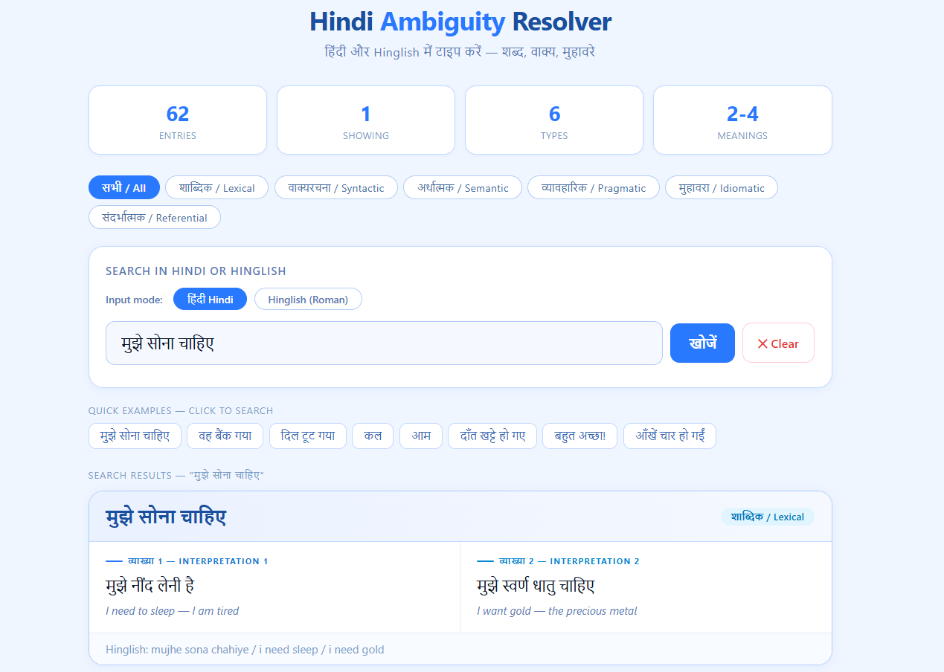
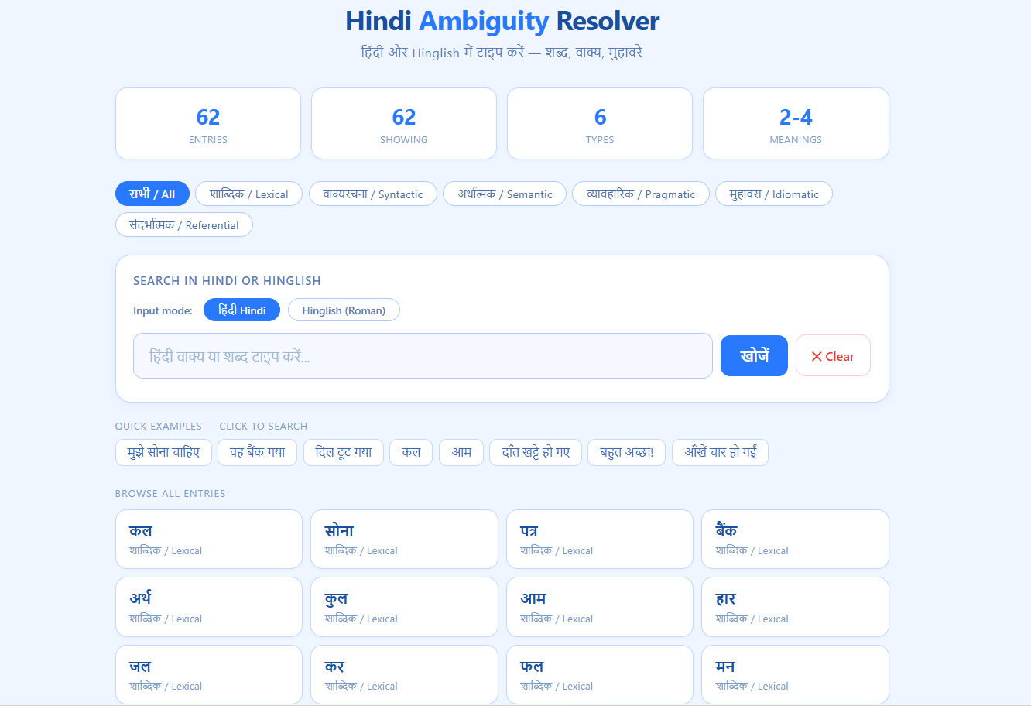
Fig 2: User Interface of Model
Chapter 8: Challenges & Solutions
Several significant issues were encountered during development. Each was systematically diagnosed and resolved. The following documents the five major challenges:

8.1 Syntax Error: Invalid Decimal Literal
Field | Detail
Problem | CSS custom properties like --r: 10px inside a Python string were being interpreted as Python code, crashing the notebook.
Root Cause | Python treated --r as a decrement operator on variable r, causing a syntax error.
Solution | Wrapped all HTML/CSS in display (HTML("""...""")) with triple quotes, isolating Python from CSS syntax.

8.2 Token Problem in Transformer Output
Field | Detail
Problem | The transformer was outputting <UNK> for almost every word, making all generated text unreadable.
Root Cause | The Sentence Piece tokenizer was mapping all unseen words to token ID 3 instead of adding them to vocabulary.
Solution | Modified encode() to auto-expand the vocabulary for unseen tokens at training time, eliminating UNK outputs.

8.3 Random Gibberish Output
Field | Detail
Problem | The model generated random gibberish after training, with no coherent interpretation structure.
Root Cause | The initial learning rate of 2e-4 was too slow for a 30-sentence training dataset; the model never converged.
Solution | Raised learning rate to 5e-3, switched to OneCycleLR scheduling, and trained for 200 epochs. Output became coherent.

8.4 RAM Crash from 2B Model Instantiation
Field | Detail
Problem | Instantiating the 2B parameter model caused the Colab runtime to crash with Out of Memory error.
Root Cause | PyTorch allocates full model weights on CPU RAM before moving to GPU — 2B params × 4 bytes = ~8GB CPU RAM spike.
Solution | Used torch.device('meta') to create the model with no data, then to_empty(device='cuda') to materialize directly on GPU.

8.5 Summary of Engineering Challenges
Challenge | Root Cause | Fix
CSS/Python syntax clash | Python parsed CSS as code | Triple-quoted HTML strings
<UNK> token flood | Tokenizer no-expand policy | Auto-expand vocab on encode()
Gibberish generation | LR too low for tiny dataset | LR 5e-3 + OneCycleLR + 200 epochs
8GB RAM OOM crash | CPU weight materialization | meta device + to_empty(cuda)

Chapter 9: Technology Stack

Full Stack Overview
Layer | Technology | Purpose
Language Model | PyTorch (torch.nn, torch.optim, torch.cuda.amp) | 2B parameter transformer training
Tokenization | SentencePiece BPE | Subword tokenization for Hindi
Quantization | bitsandbytes (optional) | 4-bit quantization for inference
Backend Language | Python 3.10+ | All ML and server-side logic
Frontend | HTML5 + CSS3 Grid + Vanilla JS ES6+ | Self-contained web interface
Runtime | Google Colab + IPython.display | Notebook execution environment
Presentation | PptxGenJS | 15 programmatically generated slides

Chapter 10: Results & Future Work

10.1 Current System Capabilities
Metric | Value
Total ambiguous entries | 60 (Track A database)
Ambiguity types covered | 6 of 6
Hinglish mappings | 100+ Roman→Devanagari conversions
Languages supported | Hindi (Devanagari) + Hinglish (Roman)
Track A response time | < 1ms (instant, browser-based)
Transformer parameters | ~2 billion
Training dataset size | 30 sentences (intentionally minimal)
Output format | Always exactly 2 interpretations
Interface dependencies | Zero external libraries
Presentation slides | 15 (programmatically generated)

10.2 Current Limitations
- Track A is limited to 60 curated entries — novel words not in the database fall back to Track B or no result.
- Track B training data (30 sentences) is insufficient for broad generalization — the model excels on seen patterns.
- No discourse context — both tracks analyze single sentences without conversation history.
- Hinglish normalization covers 100+ mappings but cannot handle all regional spelling variations.
- No confidence score output — the system does not indicate how ambiguous a query is on a scale.

10.3 Proposed Future Enhancements

Expand Track A Database
Grow the curated database from 60 to 500+ entries by mining Hindi dictionaries, idiom databases (Muhavare), and crowd-sourced annotations. Add sub-dialect entries for Braj, Awadhi, and Bhojpuri.

Fine-tune on IndicBERT / MuRIL
Replace the scratch-built transformer with AI4Bharat's IndicBERT or Google's MuRIL as the base model. These are pre-trained on 9+ billion words of Indian language data, providing far better Hindi representations than a from-scratch 2B model trained on 30 sentences.

Discourse-Level Ambiguity
Extend the system to accept multi-sentence input and resolve referential ambiguity (pronoun co-reference) across sentences using a coreference resolution pipeline.

Confidence Scoring
Add an ambiguity confidence score to each output — indicating whether a query is highly ambiguous (multiple equally valid readings) or mildly ambiguous (one dominant reading with a secondary interpretation).

Speech Input Support
Integrate with Indian ASR (Automatic Speech Recognition) models to accept spoken Hindi input, since spoken Hindi contains additional prosodic ambiguity (stress, intonation) not present in text.

